IT TICKET ANALYSIS

Objective Questions:
- What is the total no. of attributes present in the data?
A: No of attributes in the ‘ticket’ sheet: 10
No of attributes in the sheet named ‘IT Agents’: 6
- Which columns have inconsistent or missing values, and what is the count of such values?
A: None of the columns have missing values
Inconsistent Data: The columns “Severity” and “Priority” contain some cells with a value of 0, which represent unclassified or unassigned entries. These values can be considered as inconsistent data. To determine the count of such values, the COUNTIF function can be applied to the respective columns.
- Count of unclassified severity - 356
- Count of unassigned priorities – 29410
- Column Severity contains Spelling Error:
Unclasified - unclassified (Count: 356)
Mayor - Major (Count: 4836)
- Column Priority contains Spelling Error:
Unassiged - Unassigned (Count: 29410)
The spelling errors are handled using find and replace functionality of excel.
- What is the average daily ticket volume over time?
A: 53.3651
To calculate the average daily ticket volume, a Pivot Table is used. In the Pivot Table, “Fecha” is placed in the Rows area, and the count of Ticket ID is placed in the Values area to obtain the number of tickets per date. Then, the AVERAGE function is applied to these values to determine the average daily ticket volume over time.
- What is the distribution of ticket categories (e.g., Login Access, System, Software)?
A: To understand how the tickets have been distributed over different request categories, we’ll use a Pivot Table. In the Pivot table request category is placed in the Rows are and the count of Ticket ID is placed in the values area, this gives the distribution of ticket categories and also we’ll draw a pie chart to understand the distribution better
Hardware | 9733
Login Access | 29193
Software | 19570
System | 39002

- How many tickets has each agent handled?
A: To find out how many tickets each agent has handled, a Pivot Table is created. In the Pivot Table, Agent ID is placed in the Rows area, and ID Ticket is placed in the Values area with the Count function applied. This displays the total number of tickets managed by each agent.
Row Labels | Count of ID Ticket
A. Trejo | 1949
Alberto Casillas | 1974
Alberto Gastelum | 1889
Aldo Carrillo | 1966
Alfonso Barraza | 1984
Alfredo Barreras | 1920
Armando Sierra | 1890
Aurelio Tanori | 2027
Barbara Grijalva | 2003
Barraza Alberto | 1988
Darwin E. | 1945
Diana Rojo | 1927
Eduardo Luna | 1920
Elena Velez | 2021
Enrique Montiel | 1938
Estuardo Ocano | 1935
EstuardoTorres | 1942
Eva Cardenas | 1943
Flores Sierra | 1963
Galindo Guadalupe | 1991
Griselda Galindo | 1856
Guadalupe Hernandez | 1915
Guadalupe Torrico | 1987
Guadalupe Villanueva | 1958
Isela Leyva | 1968
Javier D. | 1897
Jesus Contreras | 2026
Jesus Pacheco | 1931
Jesus Grajeda | 1968
Leon Lourdes | 1961
Lopez Moran. | 1956
Lorena | 1966
Luis Arguello | 1929
Luis Torres | 1913
Marisol Piedrahita | 1960
Mata Lucero | 1969
Melinda | 2007
Miller Gaviria | 1892
Nurio Zepeda | 1946
Orci Carlos | 1926
Parra Luna | 1963
Ramon Macias | 1949
Reyna Santacruz | 1897
Rosa Olguin | 1950
Sandra Lujan | 1906
Segura Garcia | 1931
Silvia Morales | 1974
Velasquez Jose | 1949
Willyberto Gonzales | 2000
Yomaira Agudelo | 1933

- How can you extract the domain from the email addresses in the IT Agents sheet?
A: To extract the domain name from an email address, we use the following string function:
=MID(C2, FIND("@", C2) + 1, 13)
This formula locates the “@” symbol in the email address (in cell C2) and extracts the text that appears after it, which represents the domain name.
- How can you find the full name of an agent given their Agent ID?
A: To find the full name of an agent from the IT Agents sheet, we can use the VLOOKUP function by referencing their Agent ID.
For example:
=VLOOKUP([@[Agent ID]], IT_Agents[#All], 2, 0)
This formula searches for the Agent ID in the IT Agents table and returns the corresponding full name from the second column of that table.
- What is the count of each issue type (e.g., IT Error, IT Request)?
A: To find the count of each Issue Type, a Pivot Table is created. In the Pivot Table, Issue Type is placed in the Rows area, and ID Ticket is placed in the Values area with the Count function applied. This displays the total number of tickets recorded under each issue type, helping to identify which types of issues occur most frequently.
IT Error | 24278
IT Request | 73220

- What is the daily average resolution time for tickets?
A: 4.548
To calculate the daily average resolution time, we create a Pivot Table with Fecha in the Rows area and Resolution Time (Days) in the Values area. Then, set the value field to Summarize by Average. This provides the average resolution time for each date, allowing analysis of daily performance trends.

- How has the volume of tickets changed over time?
A: Based on the below "Volume Trend Over Time" chart which shows monthly ticket volume, the trend is clear: It illustrates a clear upward trend in ticket volume over the years. Between 2016 and 2017, the number of tickets remained relatively stable with minor fluctuations. However, from 2018 onward, there is a noticeable increase in ticket volume, indicating growing IT activity or demand. The upward movement continues through 2019 and 2020, where the volume reaches its highest levels, suggesting either an expansion in operations or an increase in reported issues over time.
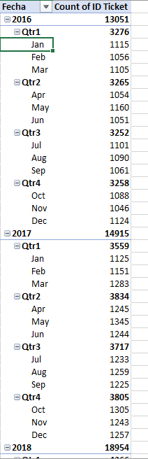

- What is the average age of the IT agents?
A: 40.0
We have columns Year, Month, and Date of Birth in the IT Agents Sheet. We use DATEDIF function to find out the age of each agent and then find the average of the column using AVERAGE function to get the average age of IT agents.
- Is there a correlation between the severity of issues and the resolution time?
A: An analysis of ticket data shows a correlation of –0.04 between Severity (Numerical) and Resolution Time (Days). Since this value is very close to zero, it indicates no meaningful correlation. Therefore, the severity of an issue does not appear to influence the time taken for resolution. We use correl function to understand the correlation between the two.
- How many categorical columns are there in the data?
A: There are 7 categorical columns in the data which are ID Ticket, Agent ID, Employee ID, Request Category, Issue Type, Severity, Priority and 5 continous columns.

Subjective Questions:
- If there is an investment, should it be used to hire more IT agents, improve training programs, or upgrade ticket management software?
A: Criteria: Determine the most impactful investment area—hiring more IT agents, improving training programs, or upgrading the ticket management software—based on key performance indicators such as average ticket resolution time (4.55 days) and average satisfaction rate (4.101).
Reference:
 | Fecha | Count of ID Ticket | Average of Resolution Time (Days) | Average of Satisfaction Rate
 | 2016 | 13051 | 4.551758486 | 3.979695043
 | 2017 | 14915 | 4.530070399 | 4.068119343
 | 2018 | 18954 | 4.558668355 | 4.091853962
 | 2019 | 21490 | 4.520800372 | 4.122382503
 | 2020 | 29088 | 4.585911716 | 4.161269252
 | Grand Total | 97498 | 4.553149808 | 4.100648218

 | Count of ID Ticket | Average of Resolution Time (Days) | Average of Satisfaction Rate
Hardware | 9733 | 7.62539813 | 4.100996609
Login Access | 29193 | 0.313808105 | 4.094508958
Software | 19570 | 5.238732754 | 4.106336229
System | 39002 | 6.615609456 | 4.102302446
Grand Total | 97498 | 4.553149808 | 4.100648218

Insights:
- Ticket volume increased steadily from 13K in 2016 to nearly 29K in 2020, showing a rising workload for IT support.
- Despite higher volumes, the average resolution time remained fairly constant (around 4.5 days), indicating decent efficiency but little improvement.
- The satisfaction rate slightly improved (from 3.98 to 4.16), suggesting moderate effectiveness of current systems but potential for better performance with enhancements.
- Ticket volumes have more than doubled from 2016 to 2020, but resolution times remain stagnant (~4.5 days), indicating growing workload pressure.
- Hardware and System tickets have the highest resolution times (7.6 and 6.6 days), suggesting inefficiencies possibly due to outdated systems or lack of automation.
- Login Access requests are resolved quickly due to automation or simpler processes.
- Satisfaction rates have improved slightly (3.98 → 4.16) but remain consistent across categories, showing that faster resolution does not yet strongly impact satisfaction
Recommendation:
- Primary Investment – Upgrade Ticket Management Software:
Automating ticket routing and improving hardware/system tracking can significantly reduce resolution times and boost overall satisfaction.
- Secondary Investment – Enhance Training Programs:
Equip agents with better troubleshooting and analytical skills, especially for Hardware and System categories, to improve efficiency.
- Conditional Investment – Hire More IT Agents:
If ticket volume continues to rise beyond 2020 trends, consider expanding the support team to balance workloads and maintain response quality.

- Which agents need additional training based on their performance metrics?
A: Criteria: Agents with resolution time more than the average resolution time and satisfaction rate less than the average needs additional training.
From the “Grand Total” row of the pivot table:
- Average Resolution Time = 4.55 days
- Average Satisfaction Rate = 4.10
So, any agent with:
- Resolution Time > 4.55 days, and
- Satisfaction Rate < 4.10,
is performing below average and may benefit from extra training.
Constraint: The analysis assumes all agents handle similar types of tickets and workloads.
Reference:
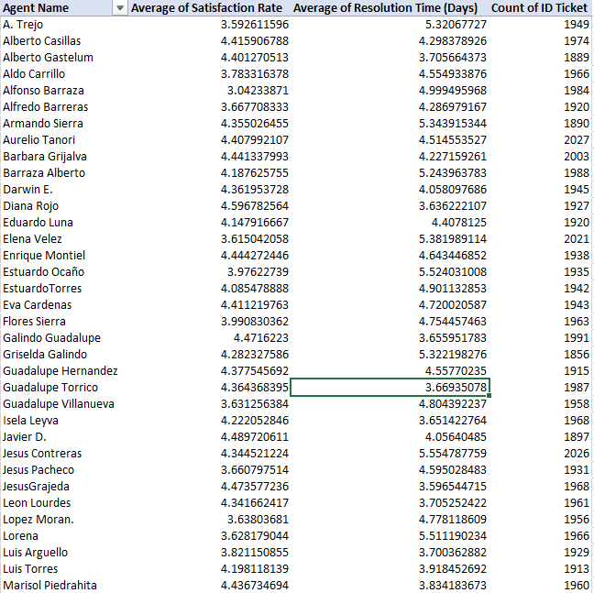
Insights:
- The average resolution time is 4.55 days.
- The average satisfaction rate is 4.10.
- Agents with resolution time > 4.55 and satisfaction < 4.10 are below average.
Agents with IDs 3, 9, 11, 41, 22, 28, 33, and 19 fall in this range.
These agents take longer to close tickets and have lower customer ratings, showing they may need support or coaching.
Recommendation: Agents with higher resolution times and lower satisfaction rates should get focused training to improve their speed and communication skills. Supervisors can arrange refresher sessions or pair them with high-performing agents for mentorship. Tracking their progress monthly can help see if training improves results. Overall, better training and regular feedback can raise both efficiency and customer satisfaction.

- Do certain categories of requests have longer resolution times?
A: Criteria:
- Compare the average resolution time of each category.
- Identify which categories take the most and least time.
Constraint: The data assumes that all requests are logged consistently and that no category is missing data.
Reference:
Request Category | Average of Resolution Time (Days)
Hardware | 7.62539813
System | 6.615609456
Software | 5.238732754
Login Access | 0.313808105

Insights: The analysis reveals that Hardware and System requests have the longest average resolution times, taking approximately 7.6 days and 6.6 days respectively. In contrast, Login Access issues are resolved much faster, indicating that such problems are generally simpler and easier to address. The longer resolution time for hardware-related issues suggests that these requests are often more complex, possibly involving physical repairs, part replacements, or coordination with external vendors. This highlights the need for better resource allocation, process optimization, and preventive maintenance strategies to improve efficiency and reduce the overall resolution time for hardware and system-related requests.
Recommendation: To reduce delays, the IT team should improve resource allocation for Hardware and System categories by keeping spare parts ready, setting clear repair timelines, and training agents to handle such issues more efficiently. For frequent software and login access problems, automated tools or self-service options can further reduce handling time.
- How effective are the current software tools in managing IT tickets?
A: Criteria: Evaluate ticket management efficiency by analyzing the severity of tickets and their assigned priority, to determine how effectively the current software tools categorize and route tickets.

Reference:

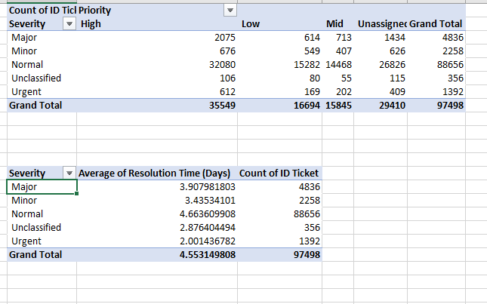

Pivot Table 1: Severity vs Priority
Shows how tickets of different severities are distributed across priority levels and whether they are being assigned properly.
Pivot Table 2: Severity vs Average Resolution Time
Indicates how long tickets of varying severities take to resolve, reflecting overall tool performance.

Insights: The data shows that a large number of tickets, especially those with normal and high severity, remain unassigned, indicating that the current software tools are not effectively routing or prioritizing tickets. Most tickets fall under the normal category, and many of them are delayed, with an average resolution time of 4.66 days. Although urgent tickets are resolved faster (around 2 days), their count is very low, showing that critical issues are not being flagged or handled promptly. Overall, the current tools lack automation and proper alignment between severity and priority, leading to delays and uneven workload distribution.
Recommendation:
- Implement automation and intelligent routing to ensure all tickets, especially high-severity ones, are assigned promptly and none remain unassigned.
- Introduce priority–severity alignment rules within the ticketing tool to ensure critical issues receive high priority automatically.
- Use real-time alerts and dashboards to highlight unassigned or overdue high-severity tickets for immediate attention.

- How has the performance of the IT support team changed over time (e.g., monthly or quarterly)?
A: Criteria:
- A decrease in resolution time means faster performance.
- An increase in satisfaction rate means better service quality.
Constraint: The analysis assumes consistent ticket types and workloads across all years.
Reference:

Insights: Based on the above graph, the IT support team's performance from 2016 through 2020 is characterized by exceptional stability and consistency across both key metrics. The Average of Resolution Time consistently hovers between 4.4 and 4.8 days, showing no significant long-term improvement in speed despite minor seasonal fluctuations. Concurrently, the Average of Satisfaction Rate is maintained at a high level between 4.0 and 4.2, reflecting reliable service quality. Notably, while the team's speed remained stagnant, their customer-facing performance saw a slight positive shift with satisfaction rates reaching their highest sustained levels during late 2019 and 2020.
Recommendation: The IT support team has shown strong consistency, which is a good sign of reliability. To make further progress, the team can focus on reducing resolution time by using automation tools, clearer ticket routing, or priority-based handling. Maintaining high satisfaction while improving speed will ensure even better overall performance in the coming years.
- If we invest more on tech (Hardware, software, etc), do you think it will improve the ticket resolution times and employee satisfaction?
A: Criteria:
- Categories with higher resolution times (like Hardware and System) show where tech upgrades could help most.
Constraint: The analysis assumes that other factors, such as training or staffing, remain constant while evaluating only tech investment effects.
- Analyzing year-over-year trends helps identify whether improvements (like system upgrades or process changes) have effectively reduced ticket counts or resolution times in specific areas.

Reference:
Request Category | Average of Resolution Time (Days)
Hardware | 7.62539813
System | 6.615609456
Software | 5.238732754
Login Access | 0.313808105
Grand Total | 4.553149808

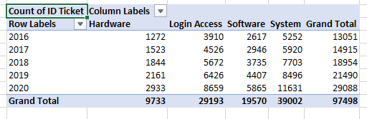
Insights:
- Hardware and system requests take the longest.
- Software requests are moderate.
- Login access is almost instant.
- System and Hardware categories show the highest resolution times and rising ticket volumes, indicating a strong need for tech upgrades and process automation.
- Login Access requests are resolved fastest, showcasing how automation and efficient tools improve response time and user satisfaction.
- The overall increase in total tickets (2016–2020) reflects growing IT demand, emphasizing the importance of investing in better hardware, software, and monitoring systems to boost efficiency and employee satisfaction.
Recommendation: Investing in technology such as upgrading hardware, implementing advanced software tools, and introducing automation can significantly enhance the efficiency of IT support. Improved tools and systems allow IT teams to resolve tickets faster, reduce bottlenecks, and focus on more complex issues rather than repetitive tasks. This not only decreases employee downtime but also boosts overall satisfaction, as staff experience quicker solutions and smoother workflows. Additionally, modernized tech can enable self-service options and better monitoring, creating a more proactive and responsive support environment.

- What are the key performance metrics for IT agents, and how can they be improved, do we need to fire any agents?
A: Criteria:
- Average Resolution Time calculated as Pivot Table → Avg Resolution_Time per agent
- Satisfaction Rate calculated as Pivot Table→ Avg Satisfaction_Rate per agent
- Tickets Handled calculated as Pivot Table→ Count Ticket_ID per agent
Constraint: Performance depends on ticket complexity and tool efficiency, not just the agent’s effort.
Reference:

Insights:
- Average Resolution Time: Most agents stay between 3.6–5.5 days, which is normal.
- Average Satisfaction Rate: Most agents are between 3.6–4.6, showing average to good satisfaction.
- A few agents, such as Jesus Contreras, Jesus Pacheco, and Jesus Grajeda, have high resolution times (around 5.5+ days) and low satisfaction (below 4.0) — meaning they need improvement.
- Agents like Darwin E., Eduardo Luna, and Aurelio Tanori show low resolution times (~3.8–4.1 days) and high satisfaction (~4.3–4.5) — indicating strong performance.
- Some agents with higher ticket counts but still good satisfaction (e.g., Luis Torres) are managing workload effectively.
Recommendation: Firing should not be the first option. Low performance may result from lack of training, outdated tools, or poor processes rather than agent capability. Focus on improving performance through training, support, and process improvements first. Only consider termination if there’s consistent underperformance despite support and improvement plans.
- How do employee demographics (e.g., department, seniority) impact satisfaction and ticket outcomes?
A: Criteria:
- Compare average resolution time and satisfaction rate across request types (departments).
- Identify which areas perform best and which need improvement.
Constraint: The analysis assumes request category represents the type of issue handled by specific departments or employee groups.
Reference:
Request Category | Average of Resolution Time (Days) | Average of Satisfaction Rate | Count of ID Ticket
Hardware | 7.62539813 | 4.100996609 | 9733
Login Access | 0.313808105 | 4.094508958 | 29193
Software | 5.238732754 | 4.106336229 | 19570
System | 6.615609456 | 4.102302446 | 39002
Insights:
- Hardware High-Priority Tickets: Take longer to resolve → satisfaction is medium → may require dedicated IT resources or faster workflows.
- Software Low-Priority Tickets: Resolved quickly → satisfaction is high → current process is efficient.
- System Tickets: Medium resolution time → moderate satisfaction → some optimization needed.
- Login Access Tickets: Quick resolution → high satisfaction → best practices can be applied to other ticket types.
Recommendation: Departments handling Hardware and System issues may need more technical staff, better tools, or clearer processes to reduce resolution time and improve satisfaction. The Software and Login Access teams are performing well and can serve as models for best practices. Sharing their methods, such as quicker ticket routing or automation, could help slower departments improve. Continuous training and workload balancing will ensure consistent performance across all employee groups.

- Identify the trends for IT support operations based on ticket volumes and satisfaction, and mention the peak and stable times?
A: Criteria: To find trends in IT operations, a Pivot Table was made with Quarter (Rows) and Count of Ticket ID and Average Satisfaction Rate (Values).
This helped track changes in ticket volume and satisfaction over time.
Criteria used: Quarterly ticket volume and satisfaction rate trends.
Constraint: Data is limited to available years, so future projections are not included.
Reference:
Insights: The ticket volume shows a clear, consistent, and accelerating upward trend over the five years.
- Stable Time (Initial Period): The volume was relatively stable, hovering around 3,300 tickets per quarter during 2016.
- Growing Trend: Volume started consistently increasing in 2017, breaking the 4,000 mark in 2018, and reaching almost 6,000 by the end of 2019.
- Peak Time: The volume saw its most significant spike during 2020, particularly from Q1 onwards, ultimately peaking at the end of the data period (Q4 2020) at approximately 7,700 tickets. The IT support team's workload more than doubled over this period.
Recommendation: The IT ticket volume has increased steadily, peaking in 2020. To maintain performance, the organization should invest in better tools, automation, and staff training. This will help the IT team manage rising workloads efficiently while keeping resolution times low and satisfaction high.

- What metrics should be included in the final dashboard to provide a comprehensive view of call center performance and guide investment decisions?
A: 1. Ticket Management

Total Tickets Logged (count of Ticket_ID)

Average Daily Ticket Volume (tickets/day)

Ticket Volume Trend Over Time (line chart, monthly/quarterly)

Ticket Category Distribution (bar/pie: Login, System, Software, etc.)

Issue Type Distribution (IT Error, IT Request, etc.)

Severity & Priority Mix (stacked bar chart)
Helps identify workload patterns & peak demand periods.

2. Agent Performance (Workforce View)

Tickets Handled per Agent (bar chart)

Average Resolution Time per Agent (compare against team average)

Satisfaction Rate per Agent (heatmap or bar chart)

Training Needs Flag (Yes/No → agents below satisfaction and above resolution average)

Helps assess productivity & identify training or resource gaps.

3. Service Quality (Customer View)

Average Resolution Time (overall trend)

Average Satisfaction Rate (trend + distribution)

Correlation: Severity vs. Resolution Time (scatter chart)

Satisfaction Trend Over Time (line chart with threshold, e.g., <80% flagged)

Helps monitor how well IT is serving employees.

4. Strategic / Investment Decision Metrics

Peak vs. Stable Periods (ticket volumes + satisfaction trends)

Cost-Benefit Indicators:

If hiring more agents → compare resolution time vs. volume spikes

If training → compare flagged agents vs. improvement opportunities

If upgrading tools → compare pre/post implementation trends (if data available)

